Ways to pay
Knox Makers’ preferred method of payment is through QuickBooks. This minimizes bank fees and automatically updates your account, reducing administrative burden.

QuickBooks offers several ways to pay: credit and debit cards, direct deposit (ACH), Apple Pay, Venmo and PayPal. You can make one-time or recurring payments on a day-of-the-month that works best for you.

If you prefer, you can still pay by check. Leave the hand-written kind in the blue metal box mounted to the wall at the front of Bay 2. Or you can have your bank send your checks to:

Knox Makers
PO Box 20474
Knoxville, TN 37940

We also accept cash. Simply seal it in an envelope labeled with your name and what the payment is for and drop it in the blue metal box.

Paying via QuickBooks

You will receive an e-mail from <quickbooks@notification.intuit.com>

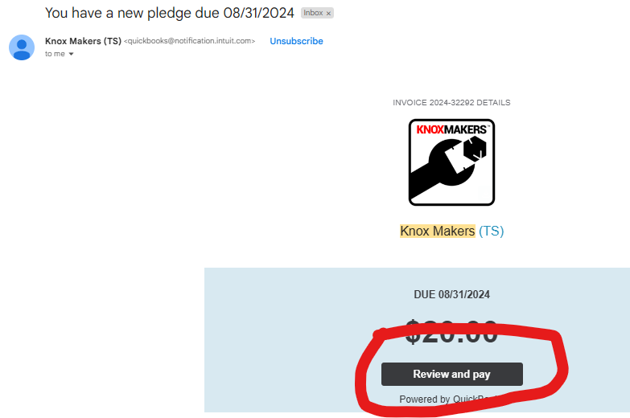
Click on the
Review and pay box

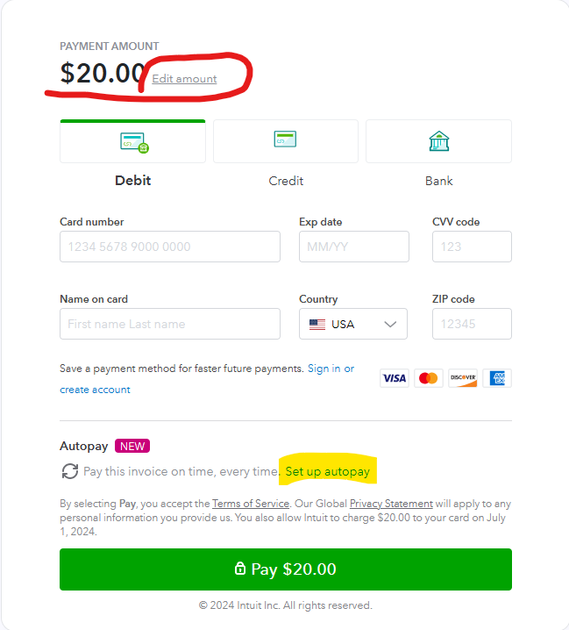
You can now choose how much you pay and how. This first screen also has the link to set up autopay.

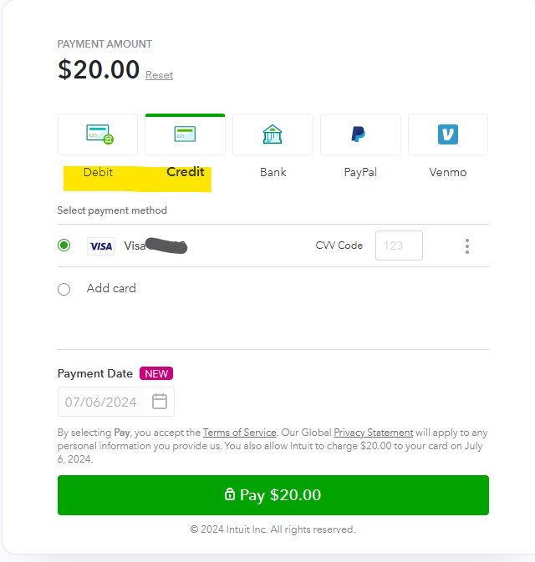

When you select debit or credit, you will be prompted for card number, security code and expiry date.

You can also choose a future date if you want.

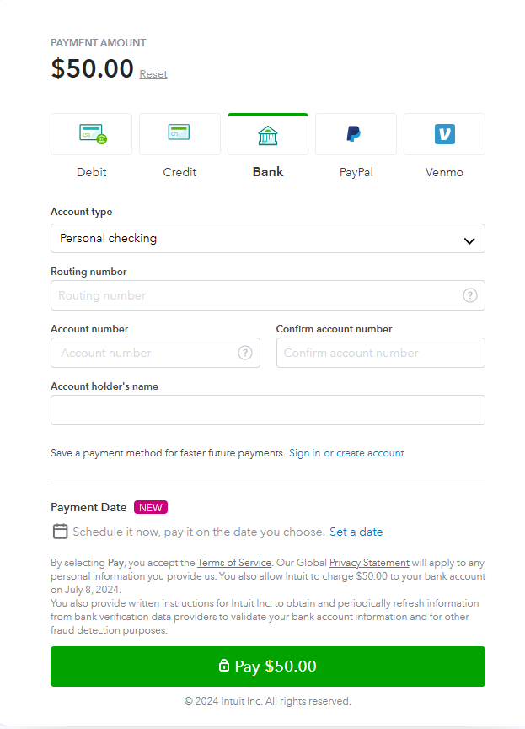

The bank option is what’s more commonly referred to as direct debit or Automated Clearing House (ACH). This is a widely-used and federally-regulated electronic fund transfer processed through the ACH network. Financial institutions encrypt these transactions, and ACH payments are protected under U.S. law.

Your bank routing number and account number can be found on your paper checks or deposit slips. If you don’t have those, call your bank for the information.

The routing number will be nine digits. The length of the bank account number will vary depending upon your bank.

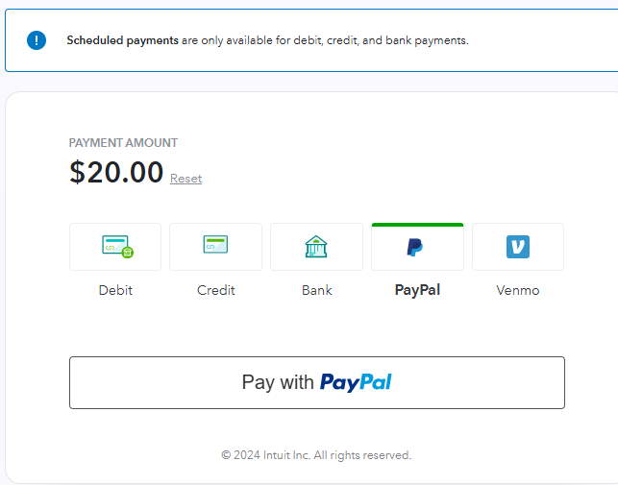

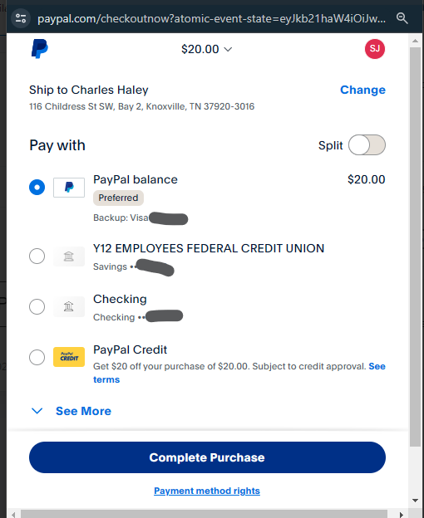
PayPal and Venmo will follow the prompts you are accustomed to.

